W-12
YEAR 10 SCIENCE
BIOLOGICAL SCIENCE
TEST 2 - GENETICS

NAME: MARK: 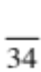

Mark | ND | NW | C | O
Mark Range | <12 | 12-18 | 19 - 25 | 26 - 34

SECTION A: MULTIPLE CHOICE

Select the best answer for each question below.
MULTIPLE CHOICE ANSWERS
1
2
3
4
5
1. If a sperm with an X chromosome fertilises an egg, what sex will the
baby be?

(a) It is difficult to tell from the information given.
(b) It has a 50% chance of being male or female.
(c) Female.
(d) Male.

2. Three different cells contain one of each of the following sets of
genes.

AA Aa aa

Which set of genes represents homozygous (pure-breeding) strains?

(a) AA
(b) Aa
(c) aa
(d) AA and aa.

3. Tongue rolling is due to the dominant gene R and the inability to roll your tongue is due to the
recessive gene r. Which of the following pairs of parents could produce a non-tongue roller
(rr)? (Hint: You may need to do some punnet squares to work it out.)

(a) RR and RR
(b) RR and Rr
(c) RR and rr
(d) Rr and Rr

4. Major differences between males and females are determined by pairs of sex chromosomes.
For example, Jane is a girl and Jim is a boy, because in each cell nucleus:

(a) Jane has two X chromosomes, Jim has two Y chromosomes.
(b) Jane has two Y chromosomes, Jim has two X chromosomes.
(c) Jane has an X and Y chromosome, Jim has two X chromosomes.
(d) Jane has two X chromosomes, Jim has an X and Y chromosome.
5. The following pedigree shows the occurrence of colour blindness in three generations of a
family.

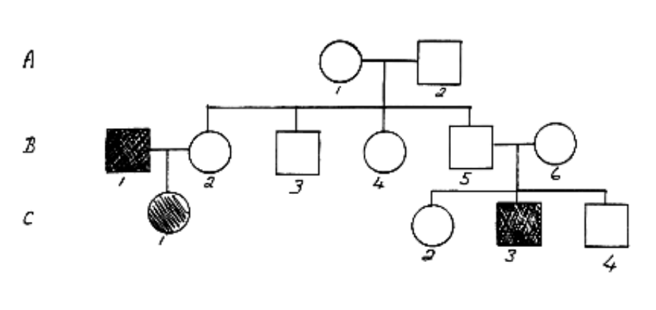

From the above family tree it can be concluded:

(a) B1 has normal vision.
(b) A2 has colour blindness.
(c) C3 is colour blind.
(d) C1 has normal vision.

SECTION B: SHORT ANSWER

1. In the table below, choose the correct statement for each word given. Write the letter of the correct statement next to the word.
(8)

WORD | CORRECT  LETTER | STATEMENT
hybrid |  | A - how an organism looks due to its genes.
gamete |  | B - hides the other gene in a pair (e.g. T).
dominant |  | C - see a new characteristic in an organism.
incomplete dominance |  | D - same genes in a pair (e.g. TT, tt).
genotype |  | E - gene that is hidden by another gene (e.g. t).
pure-bred |  | F - the genes for a particular characteristic.
recessive |  | G - sex cell of an organism
phenotype |  | H - different genes in a pair (e.g. Tt)

2. (a) The genes that determine the sex of a person are XX and XY. Using a punnet square,
show the genotype and phenotype of the possible offspring for a man and woman.

(4)

(b) If a man and woman have had 4 girls and the woman is pregnant with her fifth child,
what is the probability that the child will be a boy?

(1)

3. In pea plants, the allele for tall height (T) is dominant over the allele for short height (t).

A homozygous (pure-breeding) tall plant is crossed with a heterozygous (hybrid) tall plant.
List the possible genotypes and phenotypes of the offspring and show the probability
(percentages) for each offspring. (Set your working out clearly.)

(5)
4. (a) In budgerigars, blue colour (BB) and yellow colour (YY) show incomplete dominance,
producing a blended colour of green (BY).

A male green budgerigar is crossed with a yellow female. Show the genotype and
phenotype of the possible offspring. Show all your working.

(4)

(b) Explain how incomplete dominance is different to co-dominance.

(2)

5. The pedigree below shows the occurrence of myopia (short sightedness) in three generations
of a family.

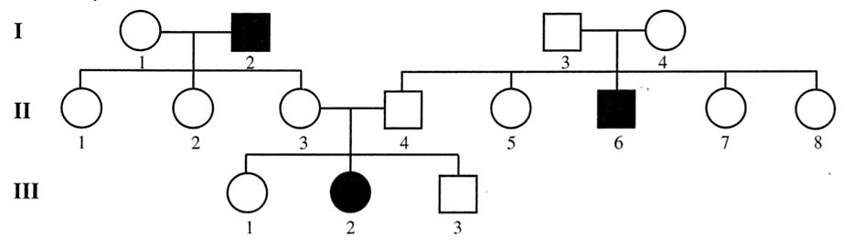

(a) Determine if the condition is dominant or recessive. Explain your answer.
(You may like to circle the part of the pedigree you are considering in your answer.)

(2)

(b) Determine the genotypes of the individuals in the pedigree. (Remember to work from
the bottom up.)

Write the genotypes for the following individuals.

Generation III Individual 1

2

Generation II Individual 3

4

Generation I Individual 1

2
(3)

